***Makwana Krishna***

***Task-1***

(1)Write a Program that displays Welcome to Java, Learning Java Now and Programming is fun.

public class Main {

public static void main(String[] args){

System.out.println("Welcome to Java, Learning Java Now and Programming is fun");

}

}

Output:

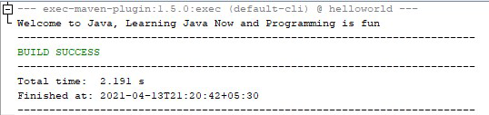

(2)Write a program that solves the following equation and displays the value x and y:

1) 3.4x+50.2y=44.5 2) 2.1x+.55y=5.9 (Assume Cramer’s rule to solve equation ax+by=e x=ed-bf/ad-bc

cx+dy=f y=af-ec/ad-bc )

import java.util.Scanner; class NewClass

{

public static void main(String[] args)

{

Scanner input = new Scanner(System.in);

System.out.println("Values from Equestion:- 1 :"); System.out.print("\r\n"+"Enter value of a : "); double a = input.nextDouble();

System.out.print("\r\n"+"Enter value of b : "); double b = input.nextDouble();

System.out.print("\r\n"+"Enter value of e : "); double e = input.nextDouble();

System.out.println("\r\n"+"Values from Equestion:- 2 :");

System.out.print("\r\n"+"Enter value of c : "); double c = input.nextDouble();

System.out.print("\r\n"+"Enter value of d : "); double d = input.nextDouble();

System.out.print("\r\n"+"Enter value of f : "); double f = input.nextDouble(); double x = ((e*d)-(b*f))/((a*d)-(b*c)); double y = ((a*f)-(e*c))/((a*d)-(b*c));

System.out.print("\r\n"+" X = "+ x + " Y = " + y);

}

}

Output:

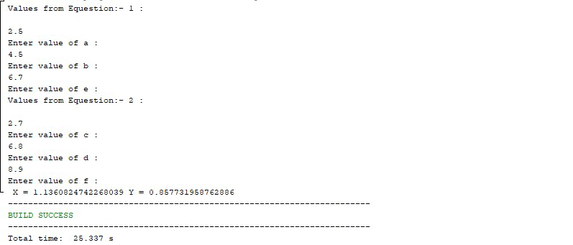

(3)Write a program that reads a number in meters, converts it to feet, and displays the result.

import java.util.Scanner;

public class MeterToFeet { public static void main(String[] args) { Scanner input = new Scanner(System.in);

System.out.print("Enter a value in Meter to convert into Feet: "); double meters = input.nextDouble(); double feet = meters * 3.281 ;

System.out.println("\r\n"+meters+" Meters = "+feet+" Feet");

}

}

Output:

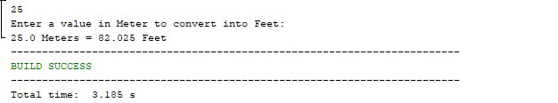

(4)Body Mass Index (BMI) is a measure of health on weight. It can be calculated by taking your weight in kilograms and dividing by the square of your height in meters. Write a program that prompts the user to enter a weight in pounds and height in inches and displays the BMI.

Note:- 1 pound=.45359237 Kg and 1 inch=.0254 meters.

import java.util.Scanner; class NewClass

{

public static void main(String[] args)

{

Scanner input = new Scanner(System.in);

System.out.print("Enter Your weight in Pound :"); double pound = input.nextDouble();

System.out.print("\r\n"+"Enter Your Height in Inch :"); double inch = input.nextDouble();

double BMI = (pound * 0.45359237) / ((inch * 0.0254)*(inch * 0.0254)); System.out.print("\r\n"+"BMI = "+BMI);

}

}

Output:

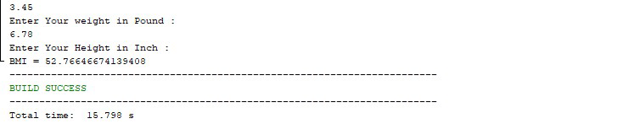

(5)Write a program that prompts the user to enter three integers and display the integers in decreasing order.

import java.util.Scanner; class Decreasing

{

public static void main(String[] args)

{ int temp;

System.out.print("Enter 1st Integer :"); Scanner input = new Scanner(System.in);

int a = input.nextInt();

System.out.print("\r\n"+"Enter 2nd Integer :");

int b = input.nextInt(); if(a<b)

{ temp=a; a=b; b=temp;

}

System.out.print("\r\n"+"Enter 3rd Integer :");

int c = input.nextInt(); if(c>b) { if(c>a)

{

temp=c; c=b; b=a;

a=temp;

} else

{

temp=c; c=b; b=temp;

}

}

System.out.print("\r\n"+"Decreasing Order :"+a+" "+b+" "+c);

}

}

Output:

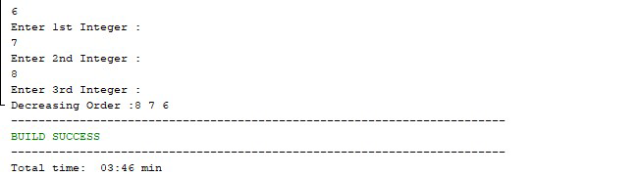

(6)Write a program that prompts the user to enter a letter and check whether a letter is a vowel or constant.

import java.util.Scanner; class NewClass

{

public static void main(String[] args)

{

Scanner input = new Scanner(System.in); System.out.print("Enter Character : "); char ch = input.next().charAt(0); switch(Character.toLowerCase(ch))

{ case 'a': case 'e': case 'i': case 'o': case 'u':

System.out.print("\r\n"+ch + " is vowel"); break; default:

System.out.print("\r\n"+ch + " is constant");

}

}

}

Output:

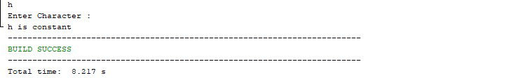

(7)Assume a vehicle plate number consists of three uppercase letters followed by four digits. Write a program to generate a plate number.

public class NewClass

{

public static void main(String[] args)

{

int alpha1 = 'A' + (int)(Math.random() * ('Z' - 'A')); int alpha2 = 'A' + (int)(Math.random() * ('Z' - 'A')); int alpha3 = 'A' + (int)(Math.random() * ('Z' - 'A')); int digit1 = (int)(Math.random() * 10); int digit2 = (int)(Math.random() * 10); int digit3 = (int)(Math.random() * 10); int digit4 = (int)(Math.random() * 10);

System.out.println("" + (char)(alpha1) + ((char)(alpha2)) + ((char)(alpha3)) + digit1 + digit2 + digit3 + digit4);

}

}

Output:

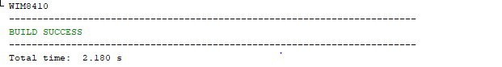

(8)Write a program that reads an integer and displays all its smallest factors in increasing order. For example if input number is 120, the output should be as follows:2,2,2,3,5.

import java.util.Scanner; public class NewClass

{

public static void main(String[] args)

{

int div=2;

Scanner input = new Scanner(System.in); System.out.print("Enter Integer Value : "); int number = input.nextInt();

while(number > 1)

{

if(number%div==0)

{

System.out.print("\r\n"+div+",");

number=number/div;

} else { div++;

}

}

}

}

Output:

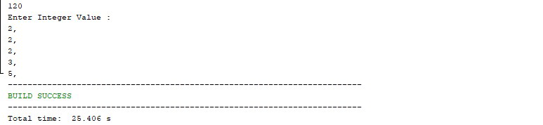

(9)Write a method with following method header.

public static int gcd(int num1, int num2).

Write a program that prompts the user to enter two integers and compute the gcd of two integers.

import java.util.Scanner; class NewClass

{

public static int gcd(int num1, int num2)

{

while (num1 != num2)

{

if(num1 > num2)

{

num1 = num1 - num2;

} else {

num2 = num2 - num1;

}

}

return num1;

}

public static void main(String[] args)

{

Scanner input = new Scanner(System.in); System.out.print("Enter First Number : "); int number1 = input.nextInt();

System.out.print("\r\n"+"Enter Second Number : "); int number2 = input.nextInt(); System.out.print("\r\n"+"GCD of "+number1+" and "+number2+" = "+gcd(number1, number2));

}

}

Output:

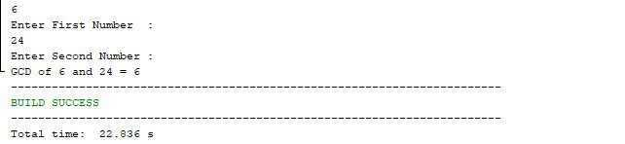

(10)Write a test program that prompts the user to enter ten numbers, invoke a method to reverse the numbers, display the numbers.

import java.util.Scanner; class NewClass

{

public static void reverse(int numbers[])

{

int j=0,temp;

while(j<=numbers.length/2)

{

temp=numbers[j]; numbers[j]=numbers[numbers.length-1-j];

numbers[numbers.length-1-j]=temp; j++;

} }

public static void main(String[] args)

{ int i=0;

int num_array[]=new int[5];

Scanner input = new Scanner(System.in);

for(i=0;i<5;i++)

{

System.out.print("Enter at Position "+ (i+1) + " : "); num_array[i] = input.nextInt();

}

reverse(num_array);

System.out.println("\r\n"+"After reversing numbers in an Array :"); for(i=0;i<5;i++) {

System.out.println("\r\n"+"Value at Position "+ (i+1) + " : "+num_array[i]);

}

}

}

Output:

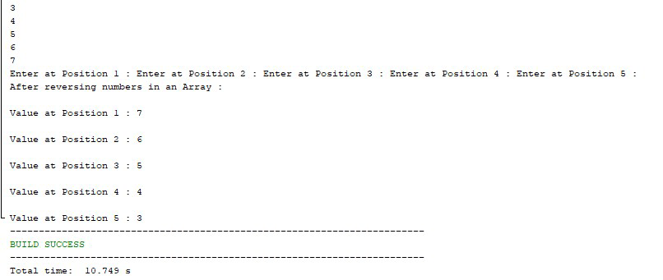

(11)Write a program that generate 6*6 two-dimensional matrix, filled with 0’s and 1’s , display the matrix, check every raw and column have an odd number’s of 1’s.

import java.util.Scanner; class NewClass

{

public static int[][] create_fill_matrix()

{

int [][]matrix = new int[6][6]; for(int i=0;i<6;i++)

{

for(int j=0;j<6;j++)

{

matrix[i][j]=(int)((Math.random()*5)%2);

} }

return matrix;

}

public static void displayMatrix(int [][]matrix)

{

System.out.print("\nMatrix Values \n");

for(int i=0;i<6;i++)

{

for(int j=0;j<6;j++)

{

System.out.print(matrix[i][j]+ " ");

}

System.out.println();

} }

public static void main(String[] args)

{

int my_matrix[][]; int i,j,cnt;

my_matrix=create_fill_matrix(); displayMatrix(my_matrix);

System.out.println("\r\n"+"Rows Having ODD no of 1s"); for(i=0;i<6;i++)

{ cnt=0;

for(j=0;j<6;j++)

{

if(my_matrix[i][j]==1)

{ cnt++;

}

}

if(cnt%2!=0)

{

System.out.println("\r\n"+"Row - "+(i+1)+" have ODD no of 1s");

}

}

System.out.println("\r\n"+"Columns Having ODD no of 1s"); for(i=0;i<6;i++)

{ cnt=0;

for(j=0;j<6;j++)

{

if(my_matrix[j][i]==1)

{ cnt++;

}

}

if(cnt%2!=0)

{

System.out.println("\r\n"+"Column - "+(i+1)+" have ODD no of 1s");

}

}

}

}

Output:

